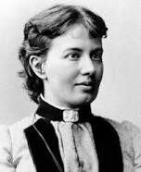
Female mathematician A was born in Moscow in 1850. When she was 11 the wall of her room was papered with pages from lecture notes and differential Maths. She was not allowed to complete her education in Russia because women were not allowed to go to University so she set up a fake marriage with a student and emigrated to Russia. Se became the first woman in Europe to get a doctorate in Maths. In addition she also wrote a memoir, various plays and a novel.

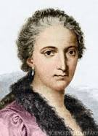
Female Italian mathematician B was born in 1718, the eldest of 21 children. She was a child prodigy and could speak Italian and French by the age of 5. By 11 she could also speak fluently in Greek, Hebrew, Spanish and German. She was referred to as the seven tongued Orator. At 14 she was studying Ballistics and Geometry. She was the first women to write a Mathematics handbook and the first women to become a maths professor at a university. She also wrote the first book on differential and Integral Calculus. She then spent 4 decades of her life studying theology and doing charitable work. She set up a hospital in her home to help the poor and sick.

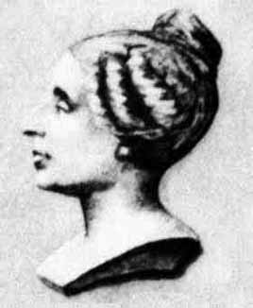
When she was 13 the Bastille fell and this French Mathematician C, also Physicist and philosopher educated herself using books from her fathers library as she had to remain indoors. Her parents did not approve of her fascination for Mathematics as it was thought inappropriate for a woman to study. At night, to stop her from studying, her parents denied her warm clothes and a fire but she took out candles, wrapped herself in quilts and did maths. One morning her parents found her asleep at her desk with the ink frozen in the inkhorn and her slate covered in calculations. They gave in. She submitted papers to a University but had to write under the name of a man. Her work was so good that many famous Mathematicians asked to meet ‘him’ and it was finally found out she was female. She made numerous contributions to the study of Mathematics, Philosophy and Psychology.
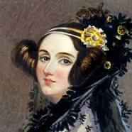
This English woman D born in 1815 created the idea of an operating system for computers. An operating system is the most important program on a computer. It manages all the computer’s resources such as memory, programs etc. Examples of today’s operating systems are Windows, Mac and Linux. She was the daughter of romantic poet George Gordon (Lord Byron) but she was taken away from him by her mother when she was only 1 month old. Her mother decided that she would be better off studying more logical subjects such as Maths and Science. She was fluent in French and also studied music and drawing. She became a countess in 1838 but lost most of her fortune through gambling.
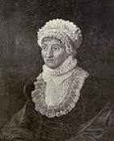
This female Mathematician E was the first woman to discover a Comet and she also helped in finding Uranus. Born in Germany in 1750, she trained a a singer but chose to move to England to join her brother who was in an orchestra but who had a hobby as an astronomer. She became an excellent Mathematician but not before she had begun to appear as a professional soloist singer. She discovered the Andromeda Nebulae and eight Comets in total. She was paid £50 yearly by King George for her work.

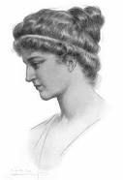
This female F was the daughter of mathematician and philosopher Theon of Alexandria. She was born around 400 A.D. She lectured in Maths and Philosophy. According to one report, she was brutally murdered by Nitrian monks who were Christians who felt threatened by her learning and depth of scientific knowledge

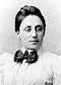
Female mathematician G was described by Einstein as ‘the most important woman in the history of Maths and Physics’. She was born in 1882 to a Jewish family in Erlangan. She originally planned to teach French and English but switched to Maths. She worked at the Mathematical Institute in Erlangan for 7 years because women were largely excluded from academic positions. She also had to publish papers under another male Mathematicians name.

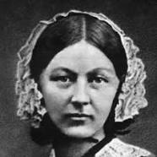
This English woman H was born in 1820 was a celebrated English statistician who was known as ‘The Lady with the Lamp’.

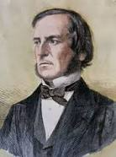
Male British mathematician and Philosopher I was born in 1815. He educated himself mostly and by 14 he was fluent in Greek, French and German by his own efforts. At the age of 15 he began teaching and set up a school of his own in Lincoln. He began to study Maths in his spare time and designed a form of Maths known as Boolean logic. And, nowadays, there is not one piece of technology that you use today that does not use Boolean logic.

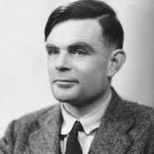
This English Mathematician, logician and cryptographer J was born in London in 1912. He was responsible for breaking the NAZI Enigma codes during World War 1 which resulted in saving thousands of lives and shortening the war by an estimated 2 to 4 years. He was also an Oympic level marathon runner and he often ran 40 miles to London for meetings when he was working on cracking the Enigma code. He cracked the code by building a cryptoanalytic machine called the Bombe. The central concept of the modern computer is based on a paper written by this man.

Answers to be given to Ms. Selkirk (A23) or emailed using contact form on this website …. Prize for 1st correct answer sheet …. Good luck

