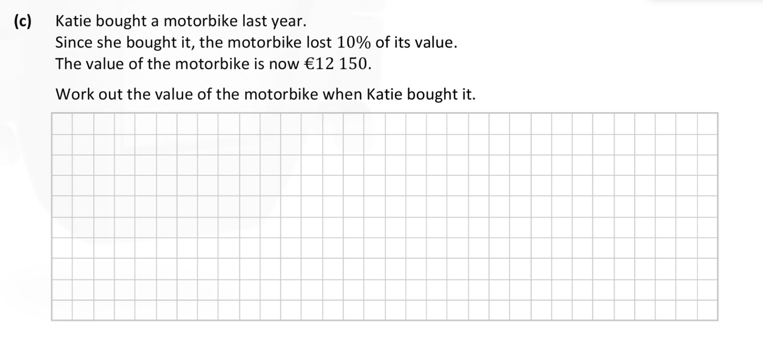
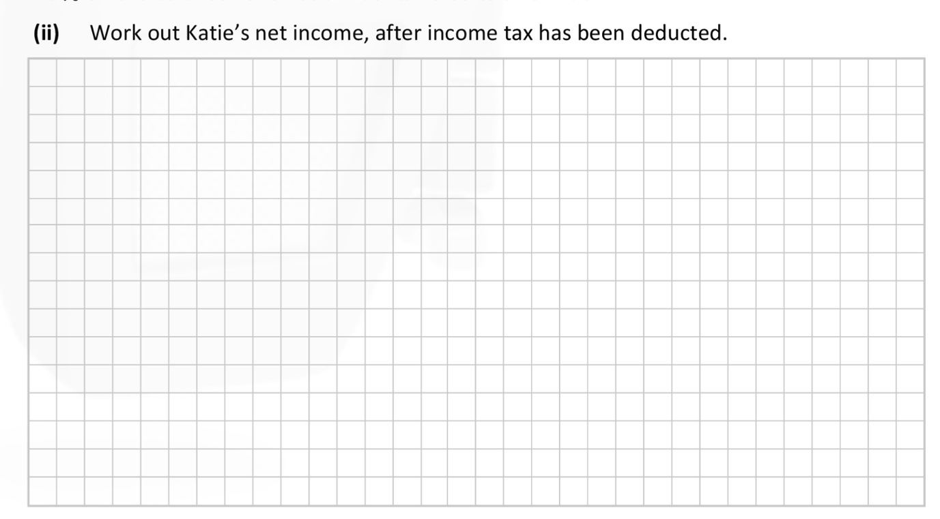
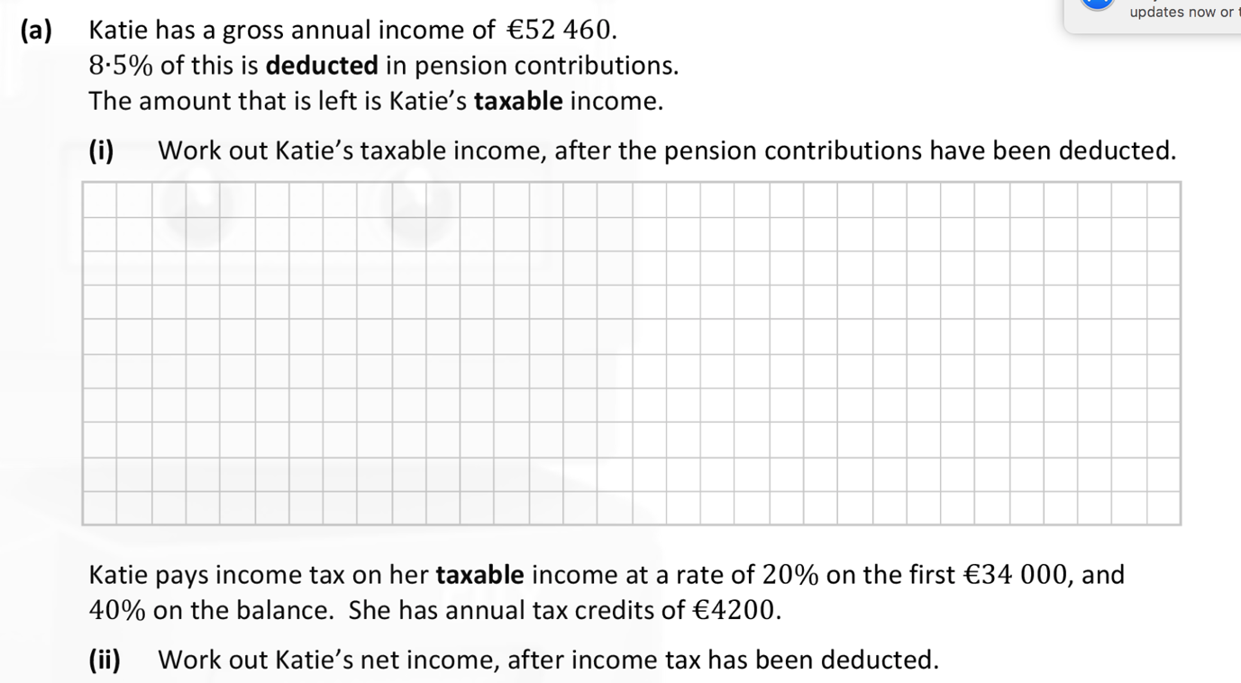

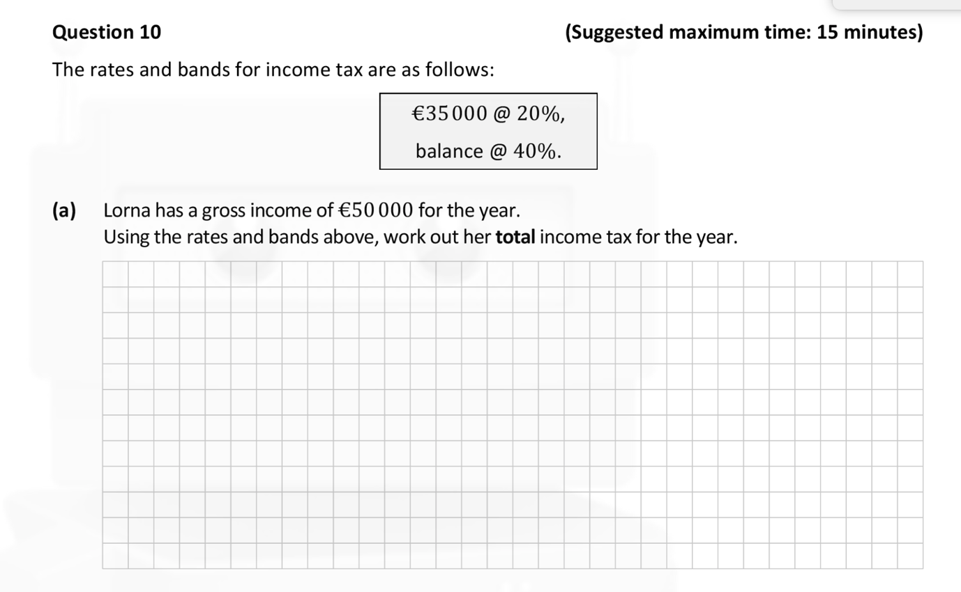

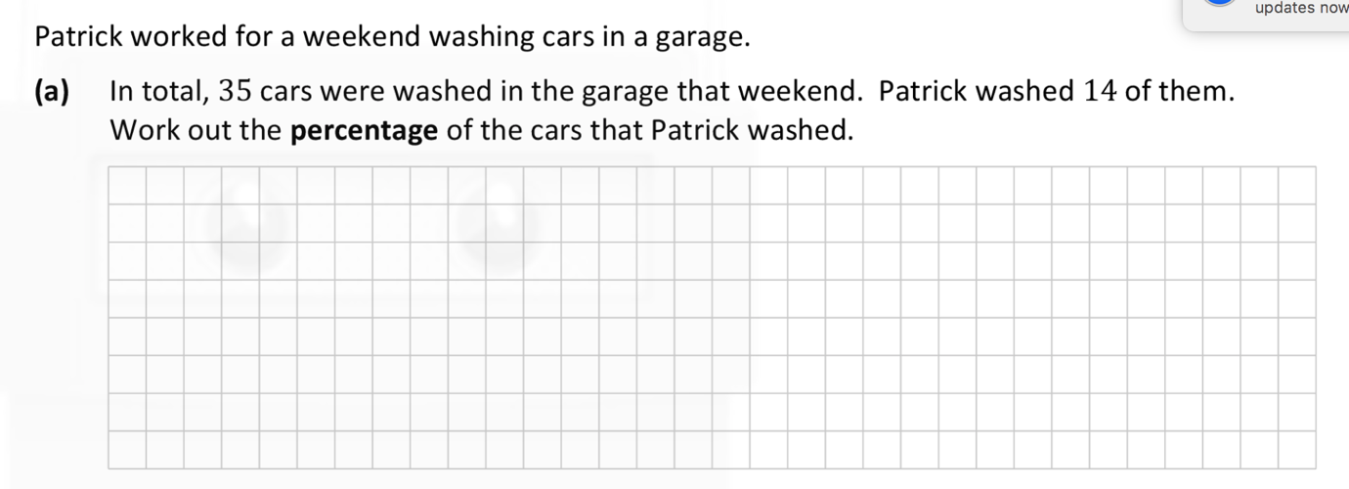

Q 4.)

John pays 10,230 euros in Income tax
His tax credits are 3200 euros
The Standard rate cut off is 35000
The standard tax rate is 21%
The high tax rate is 41%
Find John’s Gross salary

